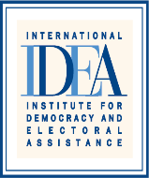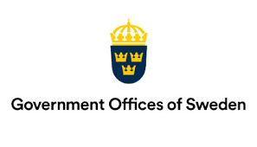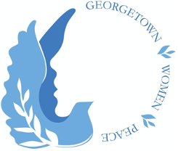
Summit for Democracy Gender Cohort
Gender Equality as a Prerequisite for Democracy, UN CSW
9th March 2023, 15:00-16:15 PM EST
Organised by the Gender Cohort Co-leads Sweden, Romania, Georgetown Institute for Women, Peace and Security (GIWPS) and International IDEA
United Nations Headquarters, Conference Room B, Conference Building, New York

Gender equality is an imperative for thriving democracies, however it has yet to be realized as a prerequisite for democracy. Democracy is being undermined by the very same forces that are pushing back on gender equality and women’s rights to equal participation and representation in public life. For instance, “gendered disinformation and online abuse against women in politics are increasingly being used with covert political, economic or social motives, to challenge women’s rights and democracy” with targeted efforts to “smother opposition voices, erode democratic processes, and silence demands for government accountability.” Consequently, it is reported that it will take up to 286 years to close gaps in legal protection and remove discriminatory laws, 140 years for women to be represented equally in positions of power and leadership in the workplace, and at least 40 years to achieve equal representation in national parliaments.

Moderator:- Rumbidzai Kandawasvika-Nhundu, Senior Advisor:-Democracy and Inclusion, International IDEA
- Overview on the Key Recommendations of the Gender Cohort on Gender Equality as a Prerequisite for Democracy; Rumbidzai Kandawasvika-Nhundu, Senior Advisor:-Democracy and Inclusion, International IDEA (10 minutes)
- Gender Equality as a Prerequisite for Democracy-why this is critical , what is the value and contribution to the Summit for Democracy and beyond the Summit? Sofia Calltorp, Ambassador for Gender Equality, Sweden (10 minutes)
- Key Reflections on Inclusion- what are the key strategies to transform the negative socio-cultural norms, practices and stereotypes that hinder the meaningful inclusion of women and the achievement of gender equality as a prerequisite for democracy? Romania (10 minutes)
- Key Reflections on Conflict prevention, peace and security- considering the challenges related to conflict prevention, peace and security for women and girls, what should be prioritised and focused on to advance gender equality in democracy? Ambassador Melanne Verveer, Georgetown Institute for Women, Peace and Security (GIWPS) (10 minutes)
- Plenary Discussions on Good Practices/Examples and Lessons on advancing Gender Equality as a Prerequisite for Democracy (25 minutes)
    - Key questions- What are the essential transformative and sustainable strategies on advancing gender equality and women’s political empowerment in democracy? What are the evident milestones that can be used as benchmarks to accelerate progress?
- Concluding Remarks

International IDEA’s Global State of Democracy Report indicates that as of the end of 2021, nearly one-half of the 173 countries assessed were experiencing declines in democracy.
https://www.concordia.ca/content/dam/artsci/research/migs/docs/WomenLeadership/WhitePaper_CanadianWomenLeaders.pdf
ShePersisted_Digital_Resilience_Toolkit.pdf
Progress on the Sustainable Development Goals: the gender snapshot 2022, UN Women and UN Statistics Division.

