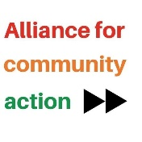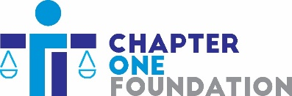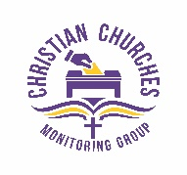
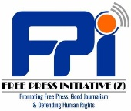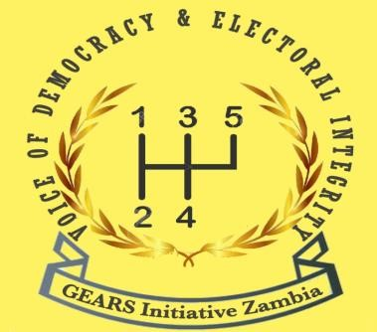

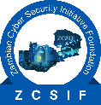

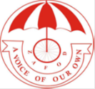


CSO Review Paper
Zambia’s 2021 Summit for Democracy Commitment:
Ensuring a Free Media

The civil society organizations and the Law Association of Zambia represented by the logos above reviewed Zambia’s commitment following the 2021 Summit for Democracy on ensuring a free media, assessed the progress made thus far, and provided direction on the way forward to realise this commitment.

Ensuring a Free Media

Media freedom is fundamental as it promotes transparency and accountability in the management of public resources and public decision-making. In a democracy such as Zambia, the role of the media cannot be overemphasized because through its effective provision of information, media plays a watchdog role on decision-makers. In addition, it empowers citizens to make informed decisions on matters of public interest. This can only be attained if individuals and journalists who express themselves through the media are not subjected to acts of harassment or reprisal by those in authority. Media, when provided with freedom to operate, offers checks and balances to the three branches of the government - executive, legislature and judiciary – thereby fulfilling its role as a fourth estate. A free media also offers platforms to members of the public for the exercise of their right to freedom of expression. It is only through such expressions that the government will be able to know issues affecting the general citizenry.

We acknowledge the efforts that the current government is putting in place to ensure that media freedom and freedom of expression of Zambians is enhanced, for instance through the abolition of criminal defamation of the President and the promotion of the right to life with the abolition of death penalty. Additionally, a slight reduction in cases of intimidation, threats and harassment has been recorded largely due to President Hichilema’s call to end caderism and intimidation of the media in the country.

Nonetheless, the media in Zambia has continued to experience acts of intimidation, harassment and threats from different actors that include political party cadres, police, members of the public and other government functionaries. In addition, the media has not been completely free in Zambia because there are instances where media houses have been reprimanded for stories aired on their platforms that did not sit well with those in authority. In a MISA report released just short of a year after the 2021 election in July 2022, thirty-four (34) journalists were reported to have been harassed, threatened and intimidated by political party cadres and officials. More arrests of media and human rights activists continued into the end of 2022 and the beginning of 2023. Examples of such incidences are represented in the table below.

Date | Example of Media Harassment & Intimidation
21/01/22 | The KBN TV station manager was summoned, interrogated and arrested by police for reporting on a leaked audio involving senior government officials.
06/05/22 | A local authority official called a board member for Kasempa Radio station in North-Western Province of Zambia demanding the dismissal of two employees who had been airing accountability programmes and influenced a traditional court to summon them and fine them for defaming him.
01/01/23 | Suspected UPND cadres blocked the Economic and Equity Party President Mr. Chilufya Tayali from featuring on a live paid for radio program at Mafken Radio in Mufulira.
12/11/22 | Police arrested 2 Muvi TV journalists as they filmed officers preparing to arrest opposition Economic and Equity Party leader Chilufya Tayali and detained the journalists for 21 hours before they were released on November 14, after signing an admission of guilt and paying a fine for disorderly conduct.

These acts of intimidation and victimization of the media have a likelihood of instilling fear in journalists and citizens. Such acts if tolerated promote a culture of censorship and impacts negatively on citizens’ right to freedom of expression.

Further, media freedom in Zambia has continued to be impacted by journalists’ poor access to information. The culture of secrecy among government officials, in which they see government information necessary for public use treated as secret/confidential and as in-house information, has persisted. Access to information is not easy due to bureaucracy and lack of decentralized information channels. Journalists in rural districts of the country are referred to provincial officials or Lusaka, which headquarters most of the government ministries or institutions for information. District officials refuse to comment on matters of public interest, including local issues affecting some communities.

Despite the abolishment of section 69 of the Penal Code Act on criminal defamation of the President on December 5th 2022, we still have existing laws that curtail the exercise of the right to freedom of expression. For instance, the Section 53 Penal Code Act Chapter 87 of the Laws of Zambia gives power to the President to declare some publications as “prohibited publications” and warrants bans of particular publication or series of publications produced by a person or associations of persons considered to contain matters contrary to public interest. It further prescribes a prison sentence of 2 years and a fine for any person who imports, publishes, sells, offers for sale, distributes or reproduces any prohibited publication. Additionally, opposition political party leaders and civil rights activists continue to face arrest under a number of other laws restricting freedom of expression, including Hate Speech (Part 4, Section 65 of CSCC Act No. 2 of 2021), unlawful assembly (Section 7 of Public Order Act Number 6 of 1965) and expressing or showing hatred, ridicule or contempt for persons because of race, tribe, place of origin or color (section 70 of Public Order Act Number 6 of 1965).

Another, section of the Penal Code inimical to freedom of expression and media freedom is Section 57, which relates to offences classified as seditious practices. Seditious practices include among them; intention to advocate the desirability of overthrowing by unlawful means the government, an action to excite disaffection against the government or among the people of Zambia, inciting violence or any offence prejudicial to public order or in disturbance of public peace and/or any intention to incite resistance or disobedience to any law. According to this section, a person who utters seditious words or prints, publishes, sells, offers for sale, distributes or reproduces any seditious publication is liable for imprisonment for seven years or can be fined, whilst those found in possession of such publication are liable for imprisonment for two years or to a fine or to both.

Therefore, the presence of these provisions in the Penal Code Act promotes acts of self-censorship among citizens and the media, which in turn affects the quality of public debate necessary in a functional democracy. They also make it hard for opposition political parties to offer constructive checks and balances to the government, as those in authority can use these provisions to persecute other political players by subjecting them to arrests on frivolous charges. These provisions of the law have been invoked by the State to prosecute citizens and opposition political parties.

The Public Order Act (POA) is another law impacting media freedom and freedom of expression in Zambia. This law restricts public gatherings, and journalists have had their coverage/reporting interrupted when police decide to disperse gatherings on the condition they lack permits. Equally, the journalists’ health or lives can be endangered when security wings try to quell unrest through use of force, such as teargas. For some without proper identification, police can end up arresting journalists like ordinary members of the public. It is therefore hoped that the now Public Gathering Bill in process will be enacted into law as soon as possible before the election period starts.

The argument behind public media serving a wide section of society is based on their very establishment as a public good. This mainly emanates from the fact that public media are funded from public funds collected through general government revenues or special income through television levies and grants for example. Secondly, public broadcasting by its nomenclature demands that there should be wide reach and variety in programming with inclusivity. It is, therefore, critical that all public media outlets endeavor to carry fair content that is representative of the various interests in society as opposed to a particular section or certain stakeholders. It is for this reason that media associations have been advocating for the true transformation from a state broadcaster into public broadcaster through harmonization of the ZNBC and IBA Acts to allow for regulation by the IBA. Media associations also desire to enhance editorial independence through the enhancement of the board appointment processes (such as reinstatement of an independent appointments committee) to reduce the real or perceived influence of the Minister of Information, who currently has the power to appoint or dissolve boards as well as review management and funding models.

The tone of the programs that are aired at ZNBC affects the reporting of issues that expose those in authority and affects the way it is expected to report as the national broadcaster. Those seen to be in the opposition are not given a fair coverage and the coverage is mostly done in favor of the party in power.

Further, the Cyber Security and Cyber Crimes Act has had a negative effect on the work of journalists, as it compels them to provide articles, documents, or computers to security wings to facilitate investigations. This can expose whistle-blowers who unearth wrongdoing in high-ranking positions or powerful entities. Such requirements are an infringement on the right to privacy and render investigative journalism challenging, especially against those in authority. The provision allowing monitoring and interception of communication by cyber inspectors is unfriendly and has forced news sources not to speak to the media, especially through phone conversations as they fear doing so exposes their information to third parties. The law, therefore, defeats the whole purpose of having the media play its watchdog role and contribute to human rights promotion and good governance. As such, the government should ensure that the process of the ongoing amendments is progressive. The government should also commit to making the amendments to the Cyber Security and Cyber Crimes Act public when finalized by the Ministry of Justice to allow space for the public and civil society to review and comment on its content prior to its submission to parliament.

